**Concept**

**Platforms:** PC (Windows 10)

**Technologies:** Unreal Engine 4

**Languages:** English

**Audience:** Anybody who wants to kill his/her time in a challenging joyful game

**Genre**: Runner, Platformer

**Mood:** A player feels joy and satisfaction from improving his skills in the game when he stays alive longer and makes better results

**Emotions:** Accomplishment, Challenge, Interest

**Rating:** Everyone 6+

**User Number:** Single player

**Gameplay time:** Unlimited

**Main mechanic:** Running (with increasing velocity), Jumping, Rolling

**Setting:** 3D modern minimalistic endless runner

**Goal:** Survive as long as you can constantly improving your result (distance covered and coins collected)

**Targeted audience**

Primarily, game is made for anybody who wants to kill his/her time. Secondly, there is a challenge as players can compete trying to beat each other.

**Game Character**

**Game mechanics and operating**

Actor moving:

A / Left Arrow – move to the left line

D / Right Arrow – move to the right line

Space / W / Arrow Up – jump

Left Shift / S / Arrow Down – roll

Shift + Space [main screen] – to start the game

R [game over screen] – to restart the game

Esc (during run) – to pause / unpause

Esc [main and game over screens] – to exit the game

**Specific action**

**Interface**

**Main screen**

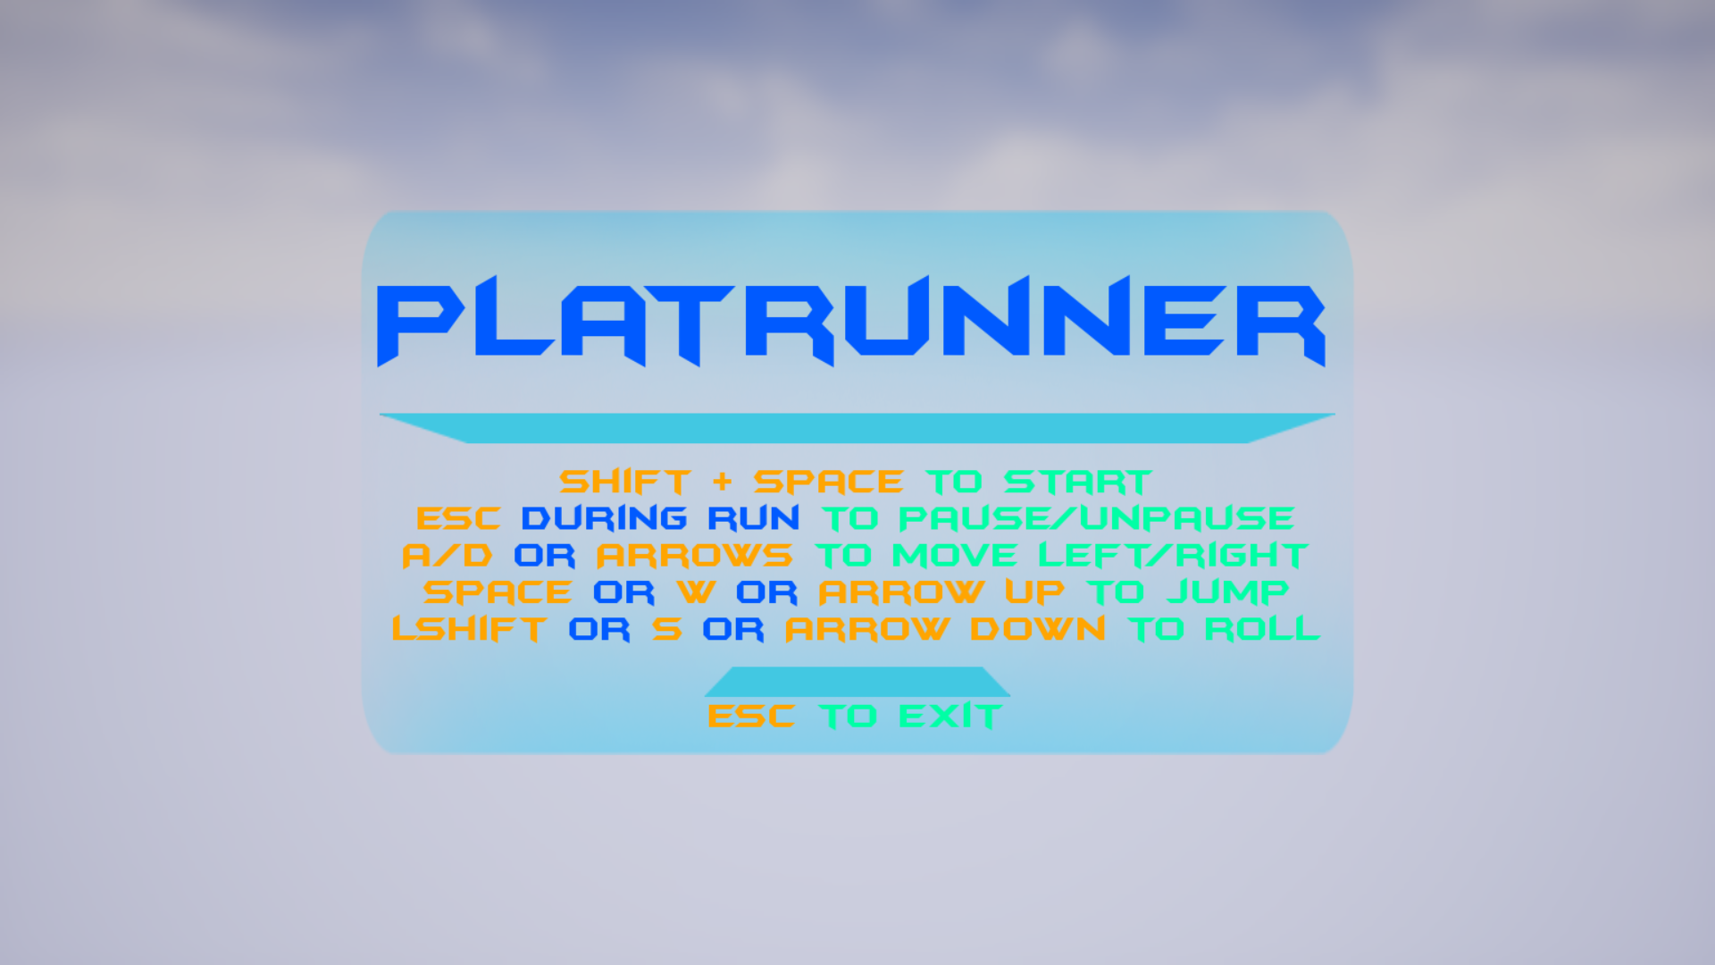

Initial screen with game title and controls description. Opened right after the game was launched or after restart.

**Main screen (run screen)**

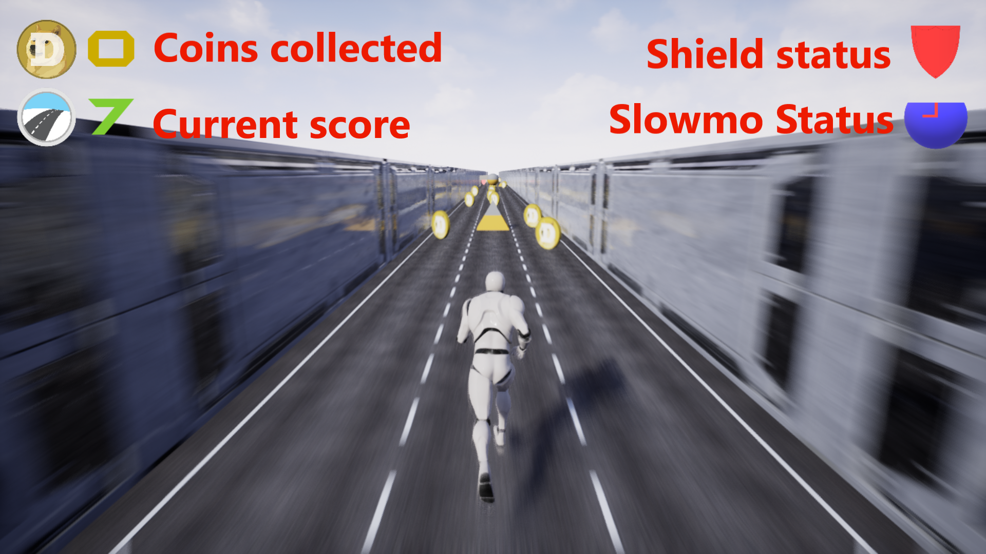

**Coins collected** shows how many coins the player has picked since the game (current run) began.  
**Current score** – how much distance player has traveled in the current run (calculated as tiles passed multiplied by a coefficient).

**Shield status** – this progress bar shows how much longer the shield boost will be active.

**Slowmo status** – this progress bar shows how much longer the slowmo boost will be active.

**Pause screen**

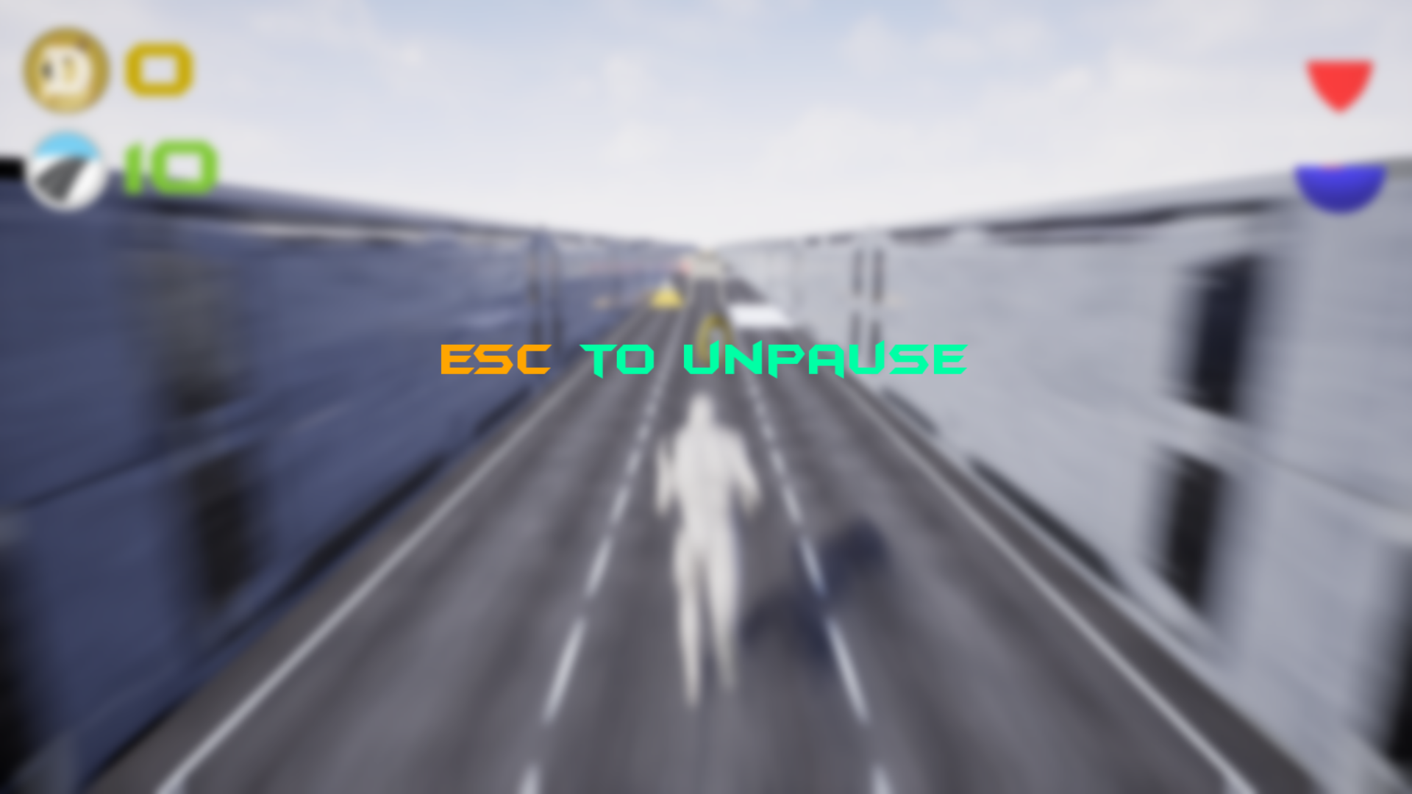

Opened when Esc was pressed during run. Can be closed with clicking Esc again.

**Game Over screen**

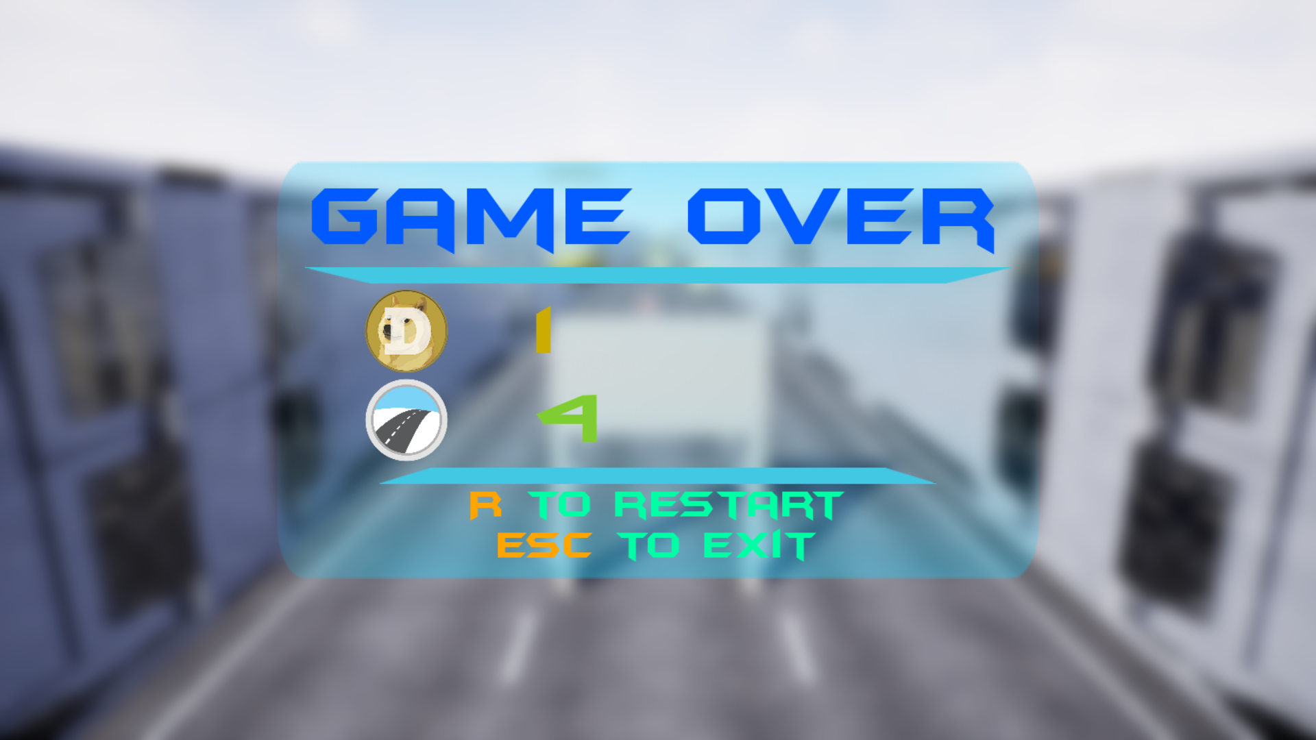

Displayed when the player has died (bumped into an obstacle or fell of the track).

**Gameplay map**

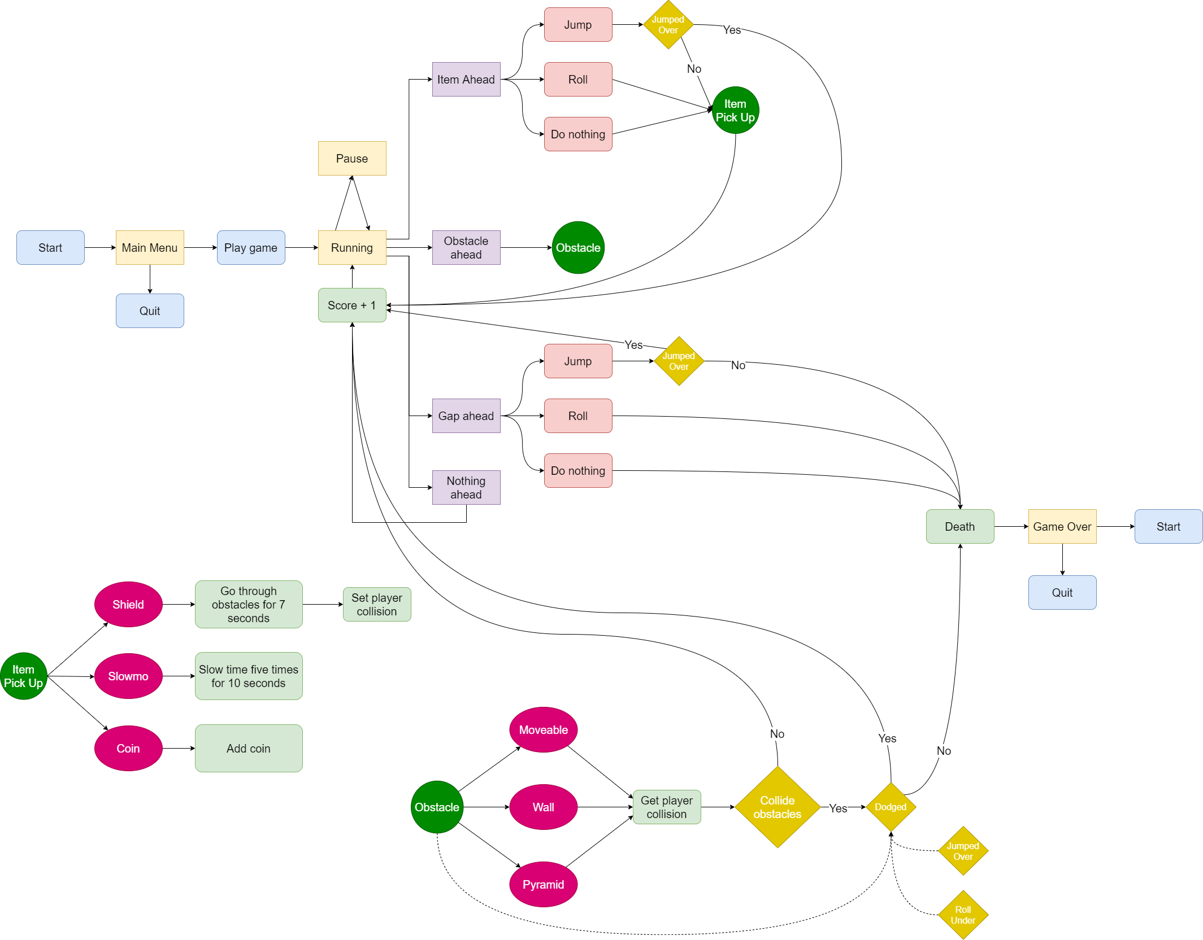  
Attached separately.

**Visual**

From a visual point of view, the game has a modern minimalistic design. Main character, tiles, obstacles and items follow same style (one color or 2 contrasting colors). Screens utilize more colors to highlight important features.

**A tile**

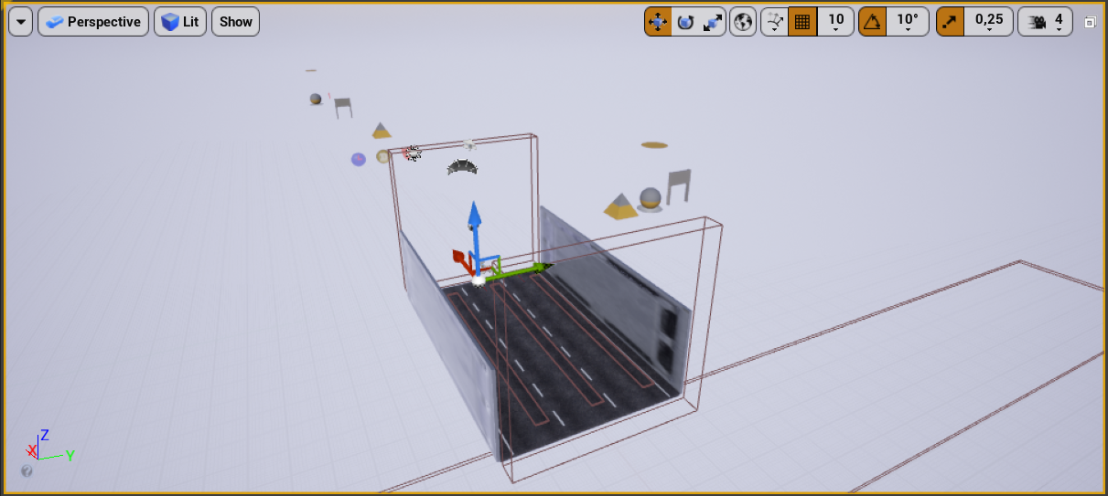

**Obstacles**

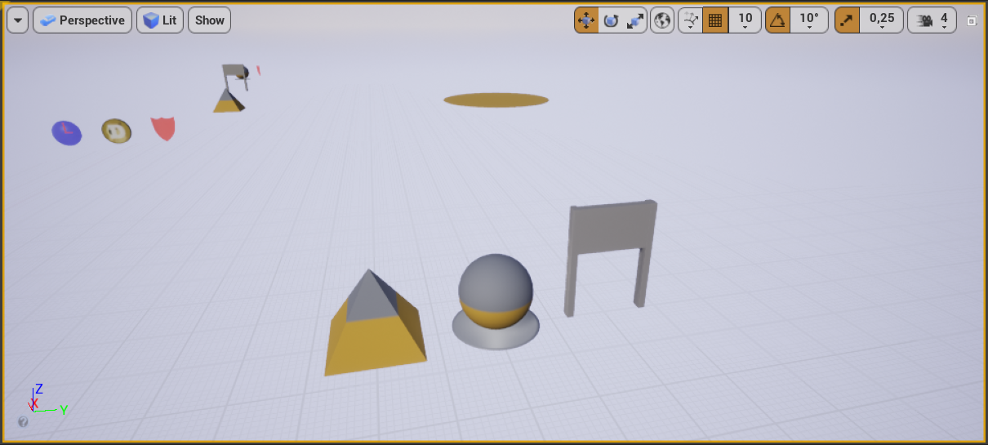

**Items**

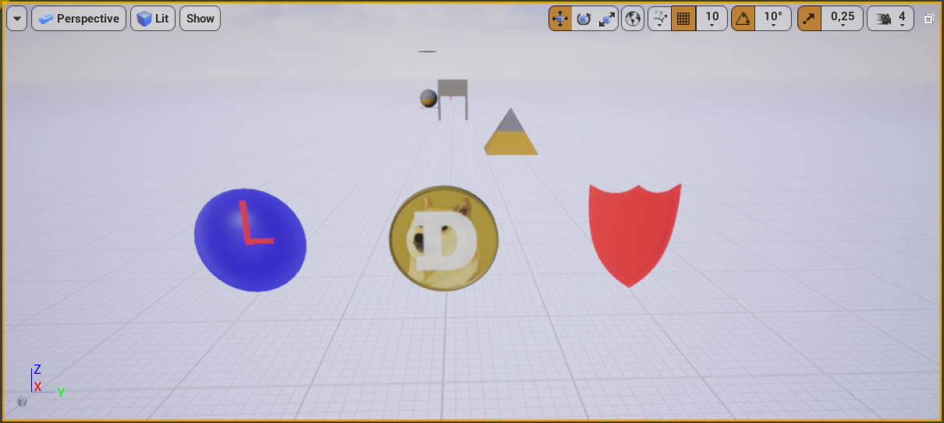

**Level Design**

The game features a procedural world generation.

Initially, a save path of 5 tiles without obstacles (and items) are spawned to prevent the player from dying right when he starts the game. Afterward there are 10 tiles spawned ahead of player. Tiles what were already passed by the player are deleted in 2 seconds.

Each tile has 3 lines. A tile is spawned with a random number of gaps (about spawn chance read below in balance section). A tile has a random number of obstacles on it (one for each nonempty [without gap] line), so obstacles can be spawned only in a single location on each line. If a tile to be spawned is not save (has obstacles or gaps), it will have a save tile before and after itself (it makes game playable when character movement speed is nearly maximal).

A tile has a random [from 0 to 5] number of items on it.

**Balance**

Player speed is increased from 1500 to 3000 gradually as player gets a determined number of scores. If a player falls of the tile, he dies same as when he hits an obstacle (without shield boost). Shield boost protects player from hitting obstacles (for 7 seconds), slowmo boost slows time 5 times [except for the player] (for 10 seconds). Both boosts are rechargeable (if a player takes a new one, while the previous is active, boost expiration time will be renewed).

**Generator (randomizer)**

Spawn chances depend on a current difficulty which is increased as player passes the level. There are three levels: easy, medium and high.

Easy [starts from the 6th tile]

|  |  |
| --- | --- |
| Object | Chance (% out of 100) |
| Tile with a gap | 20 |
| Tile with an obstacle | 20 |
| Save tile | 60 |
| 3 gaps | 10 |
| 2 gaps | 30 |
| 1 gap | 60 |
| Obstacle moveable | 20 |
| Wall (upper) | 30 |
| Pyramid | 50 |
| Shield | 3 |
| Clock | 3 |
| Coin | 94 |

Medium [starts from the 301st tile]

|  |  |
| --- | --- |
| Object | Chance (% out of 100) |
| Tile with a gap | 30 |
| Tile with an obstacle | 30 |
| Save tile | 40 |
| 3 gaps | 20 |
| 2 gaps | 30 |
| 1 gap | 50 |
| Obstacle moveable | 30 |
| Wall (upper) | 30 |
| Pyramid | 40 |
| Shield | 4 |
| Clock | 4 |
| Coin | 92 |

Hard [starts from the 1001st tile]

|  |  |
| --- | --- |
| Object | Chance (% out of 100) |
| Tile with a gap | 40 |
| Tile with an obstacle | 40 |
| Save tile | 60 |
| 3 gaps | 33 |
| 2 gaps | 33 |
| 1 gap | 34 |
| Obstacle moveable | 33 |
| Wall (upper) | 33 |
| Pyramid | 34 |
| Shield | 6 |
| Clock | 6 |
| Coin | 88 |

**Artificial Intelligence**

None

**History**

None